Nama : Hafizh Umar syafiqh

NIM : 18090138

Kelas : 5D

PRAKTIKUM 2

1. Source Code

latihan1-> application/controller

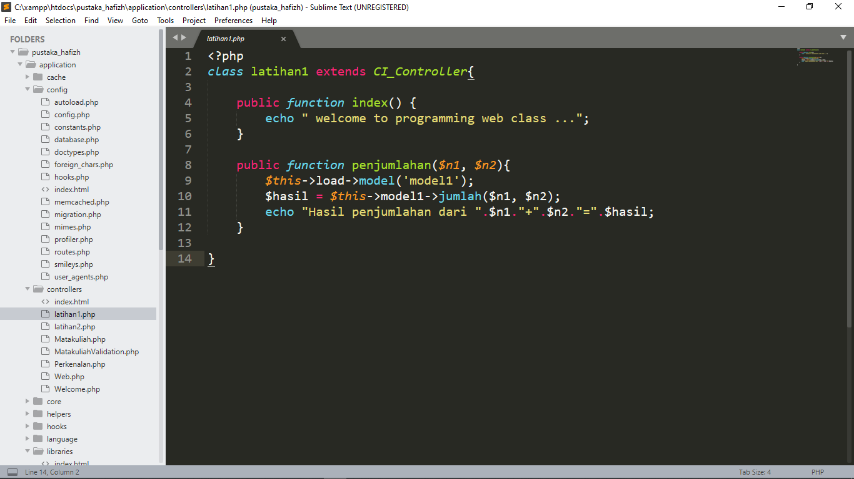

latihan2 -> application/controller

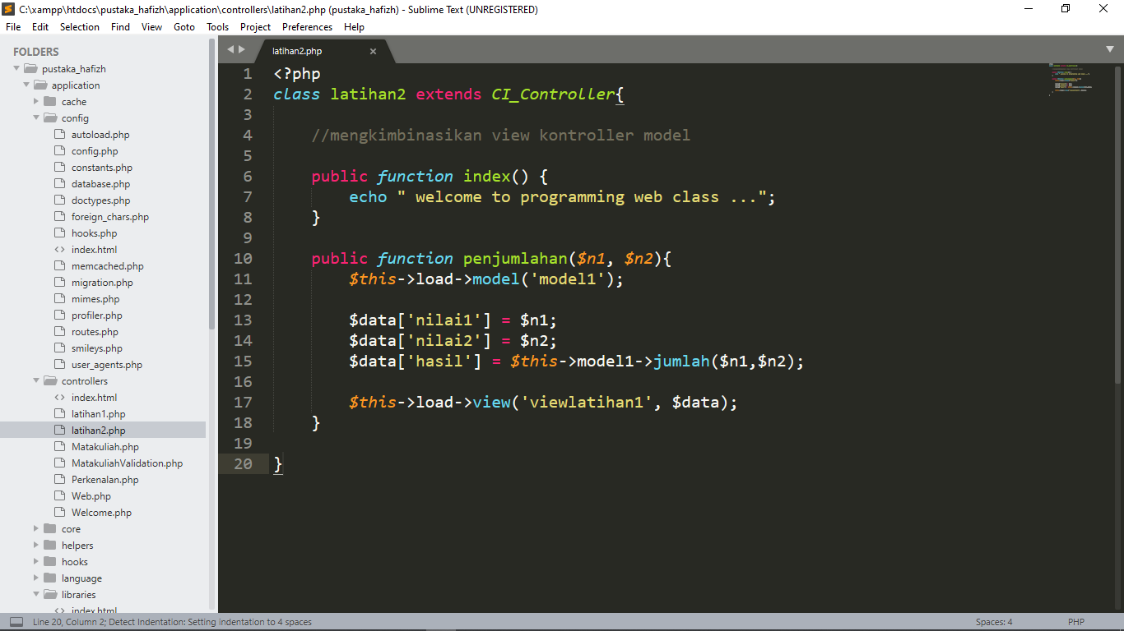

model1 -> application/model

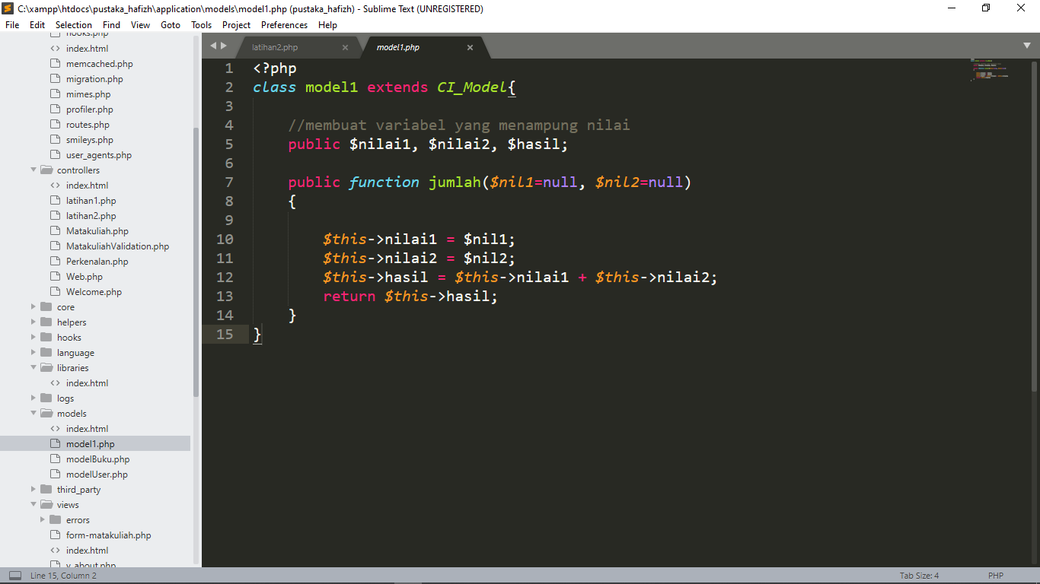

viewlatihan1.php->application/view

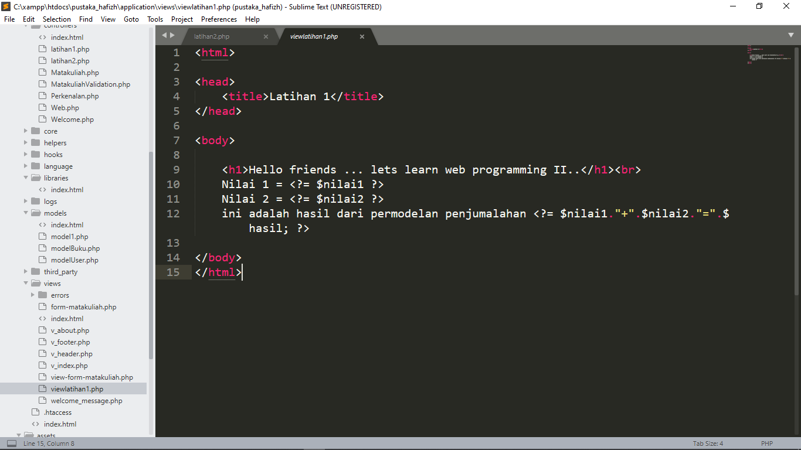

1. URL

<http://localhost/pustaka_hafizh/index.php/latihan2>

http://localhost/pustaka_ hafizh /index.php/latihan2/penjumlahan/5/7

<http://localhost/pustaka_ hafizh /index.php/latihan1/penjumlahan/10/15>

1. Capture Hasil

**Hasil run latihan 2**

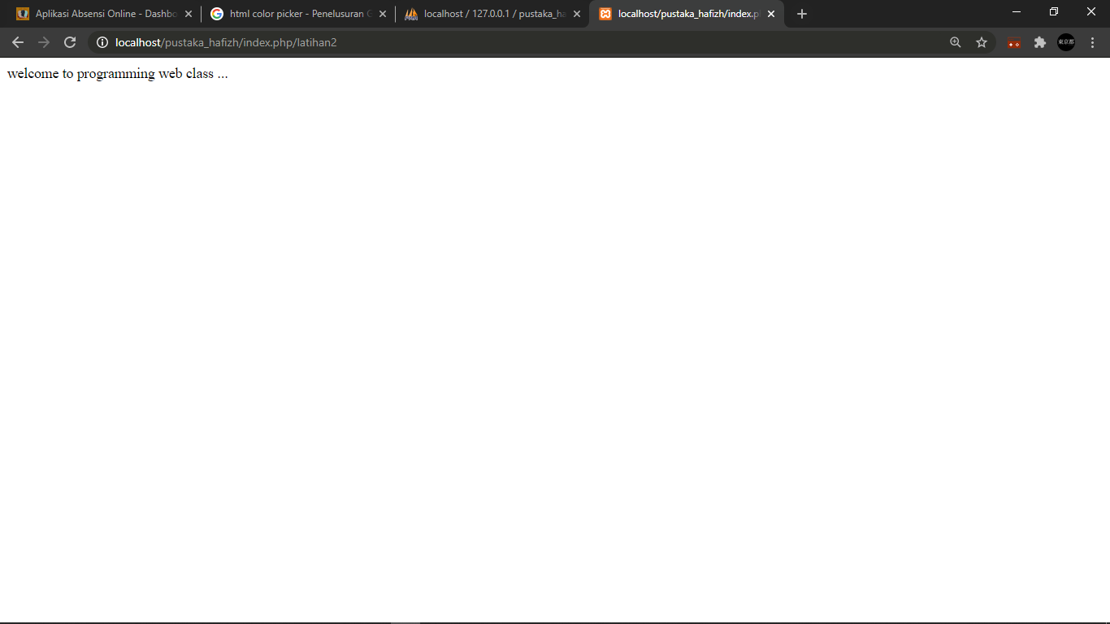

**Hasil run penjumlahan latihan 2**

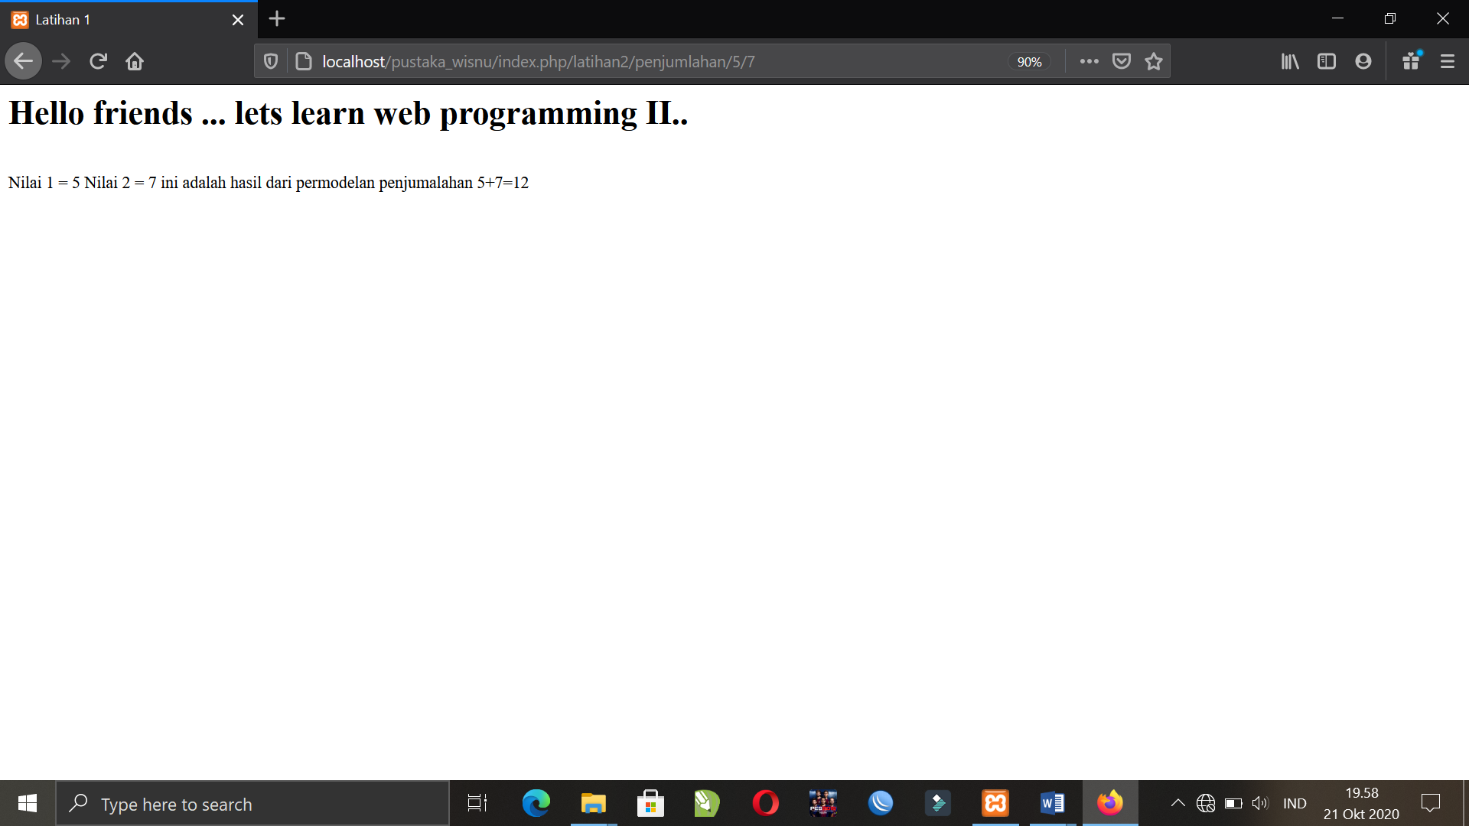

**Hasil run penjumlahan latihan 1**

